9.82: (a) The kinetic energy of the falling mass after 2.00 m is The change in its potential energy while falling is
The wheel must have the “missing” 56.8 J in the form of rotational KE. Since its outer rim is moving at the same speed as the falling mass, 5.00 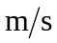:

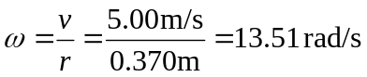
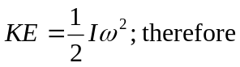
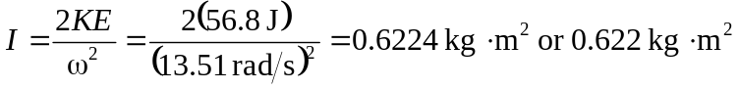

(b) The wheel’s mass is 280 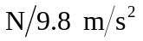= 28.6 kg. The wheel with the largest possible moment of inertia would have all this mass concentrated in its rim. Its moment of inertia would be

The boss’s wheel is physically impossible.

